AiHouse 3D Software Update
Date: September 1th , 2020
Version number: V4.0.0.388

New Function details
【Basic Module 01】Intelligent Sample
Description:
1.Enterprise designers can use the materials to design in intelligent sample .
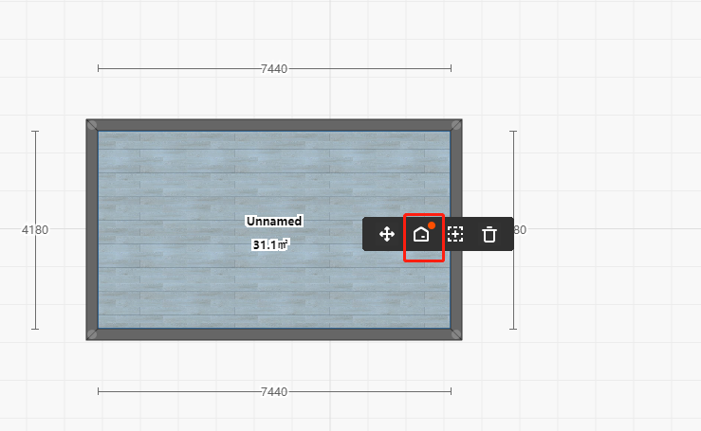
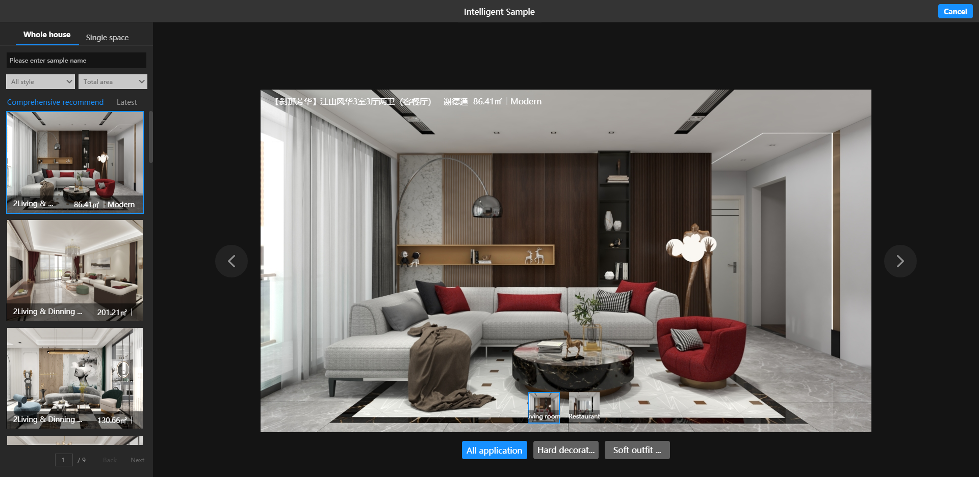

【Aluminium door Module 01】Add Sun room
Description: Users can enter the sun room module for sun room design.
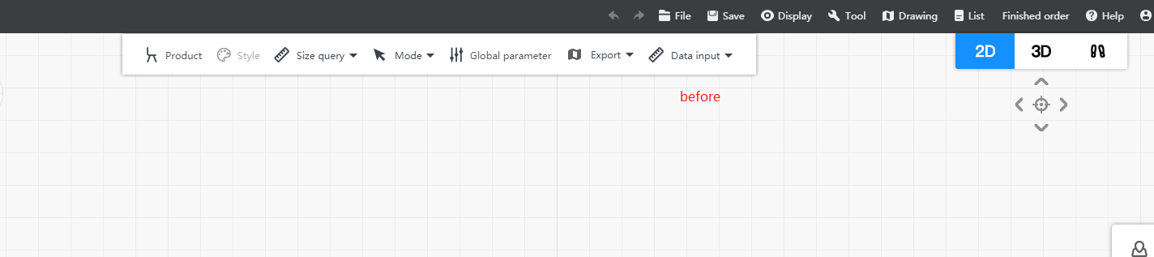

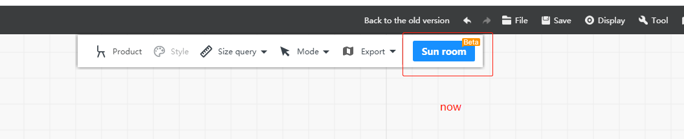

【Free Modeling 02】Import DWG/SKP format files
Description: The free modeling support dwg/skp file import, and can do secondary editing
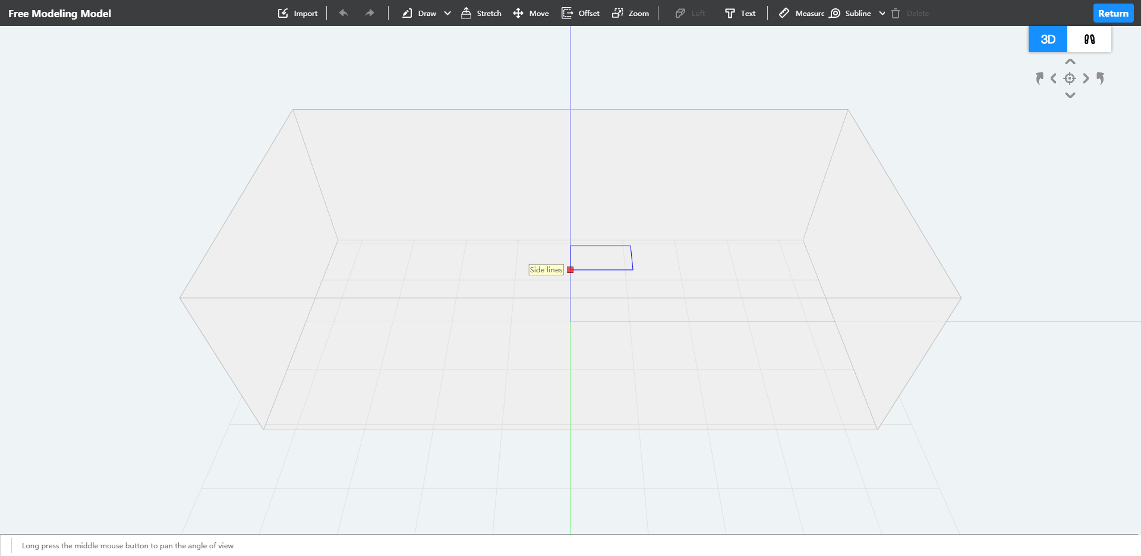
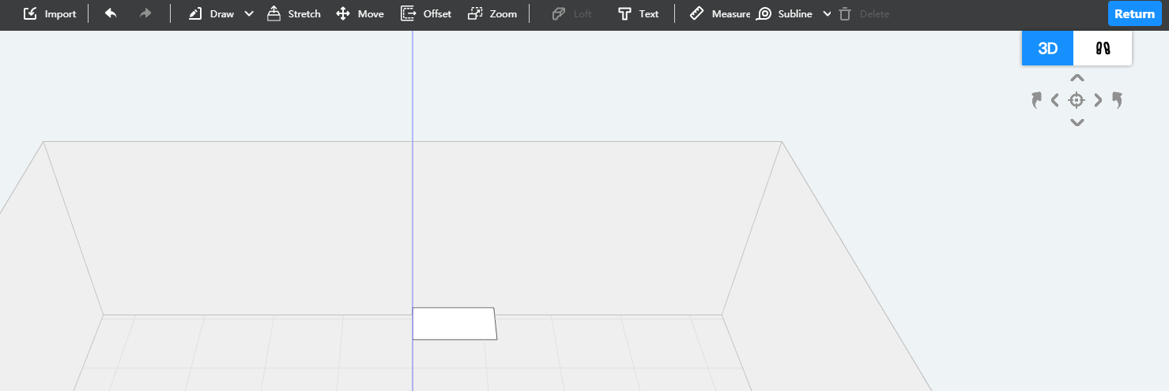

【Basic Module 01】Add structural components
Description: The flue can be use in structural components .
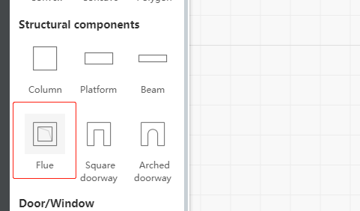

【Ceiling Module 01】Ceiling
Description:
- Solve the automatic installation of plate lines and parameter adjustment
- Intelligent adaptation of wall panel scheme, intelligent modification of wall panel parameters
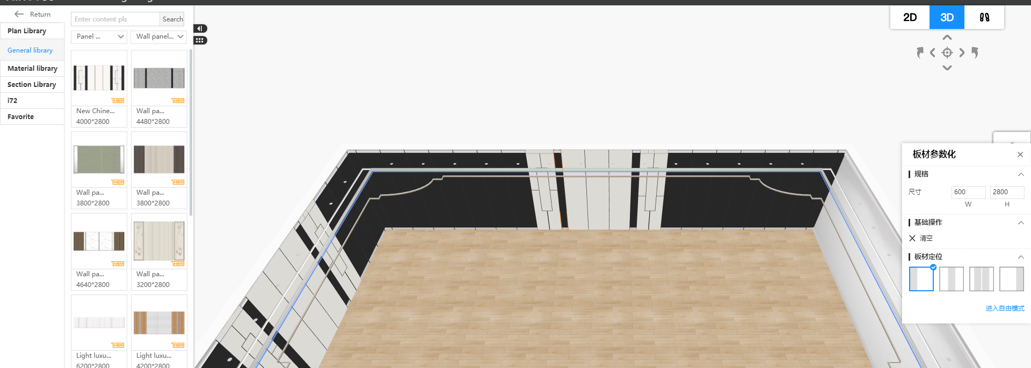

【Ceiling Module 02】Ceiling
Description: The special shape can be offset and the offset direction is positioned according to the mouse position
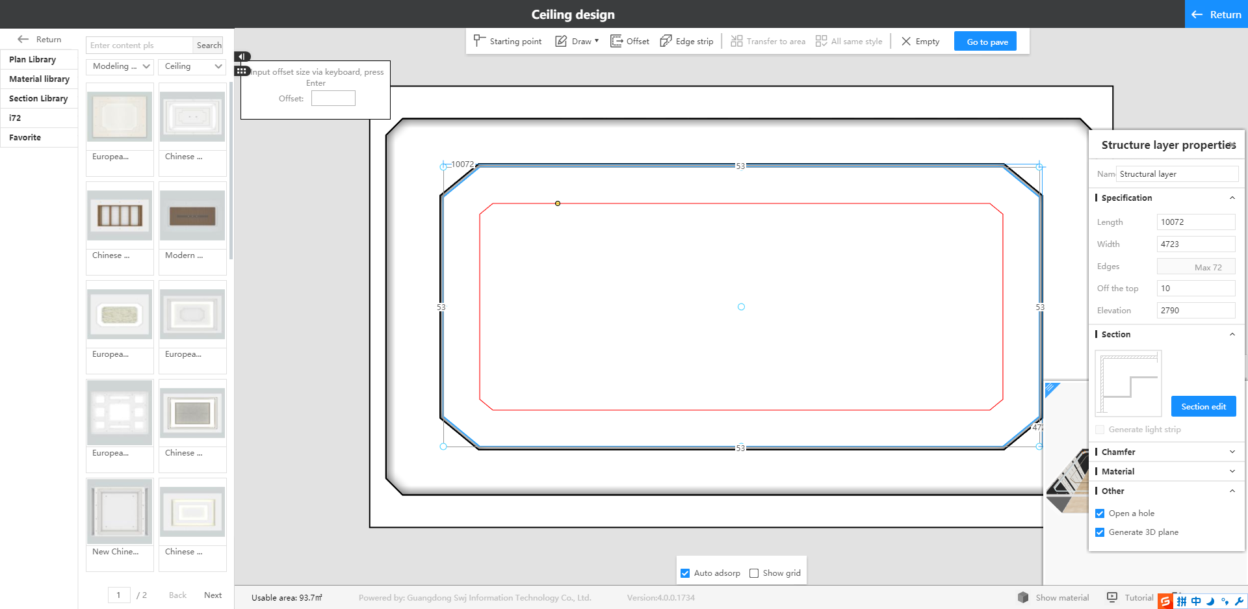

New optimization details
【Base Module 01】: Drawing
Description: Optimization of the height limitation of floor Drawing
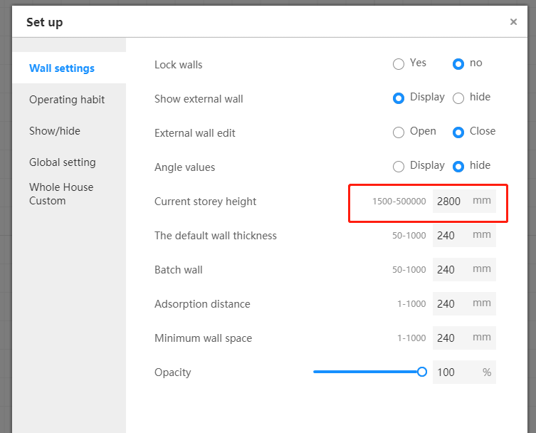

【Door/Windows 01】: Ruler display
Description:
- Mutual absorption of products and customized doors or windows
- The product ruler location display
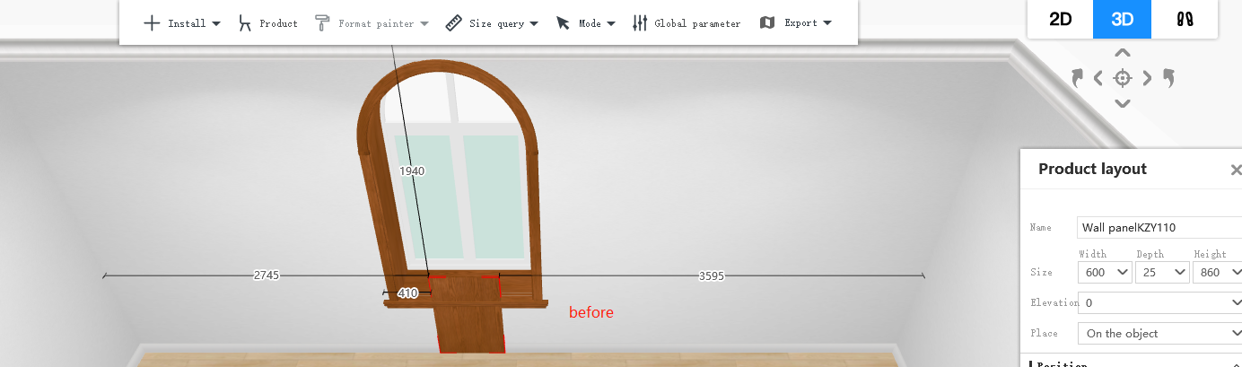
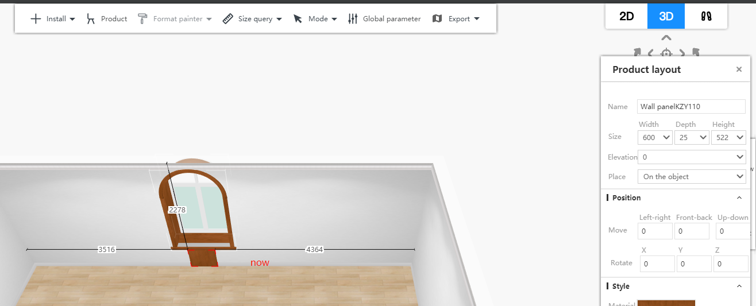

【Shower room 01】: shower room
Description:
- The shower room automatically adapts the width according to the inner space of the wall
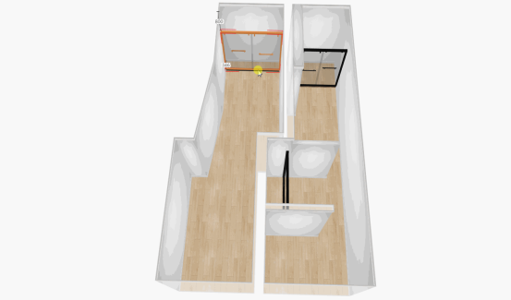

【Bathroom cabinet 01】: Slink
Description:The basin protruding from the front water stop, automatically cuts the cross section of the front water stop and the opening
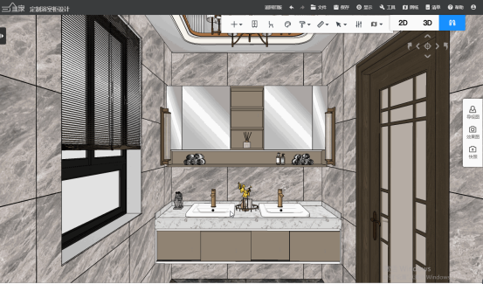

【Bathroom cabinet 02】: Sink installation
Description:Cancel the electrical hardware entrance, and put the star basin installation entrance to the first level menu display
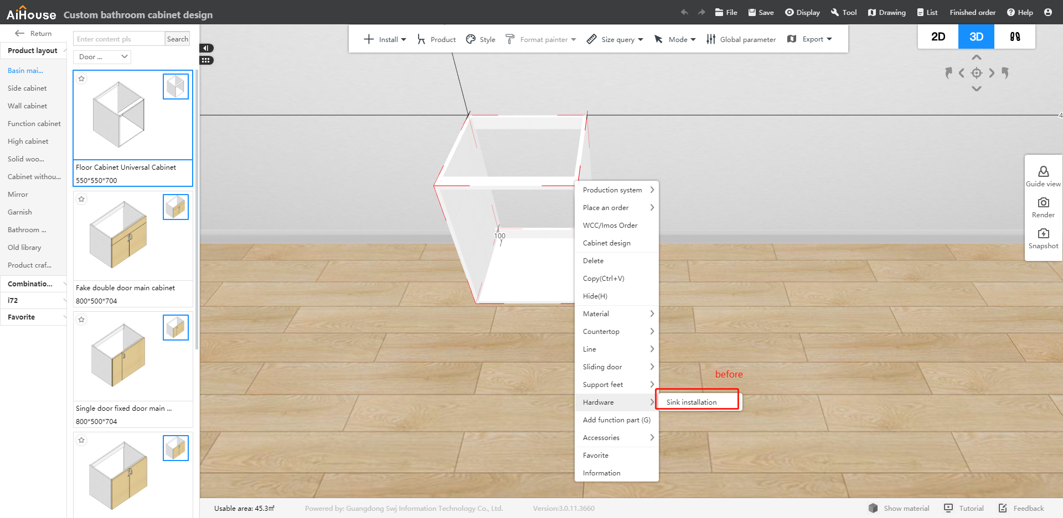
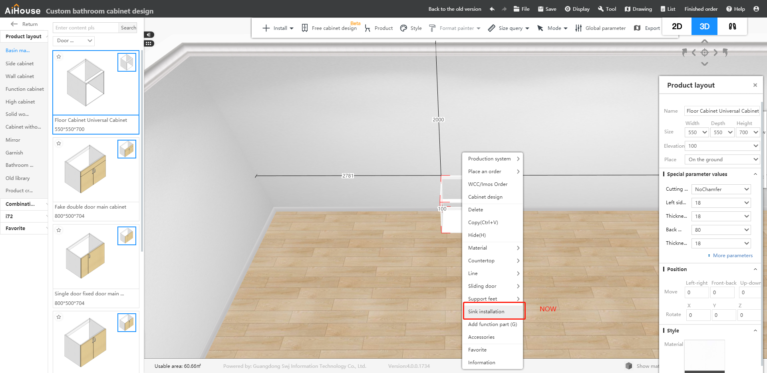

【Kitchen cabinet Module 01】Panel point editing
Description:
- The vertices and dots of the arc type can be dragged and the radius value can be modified
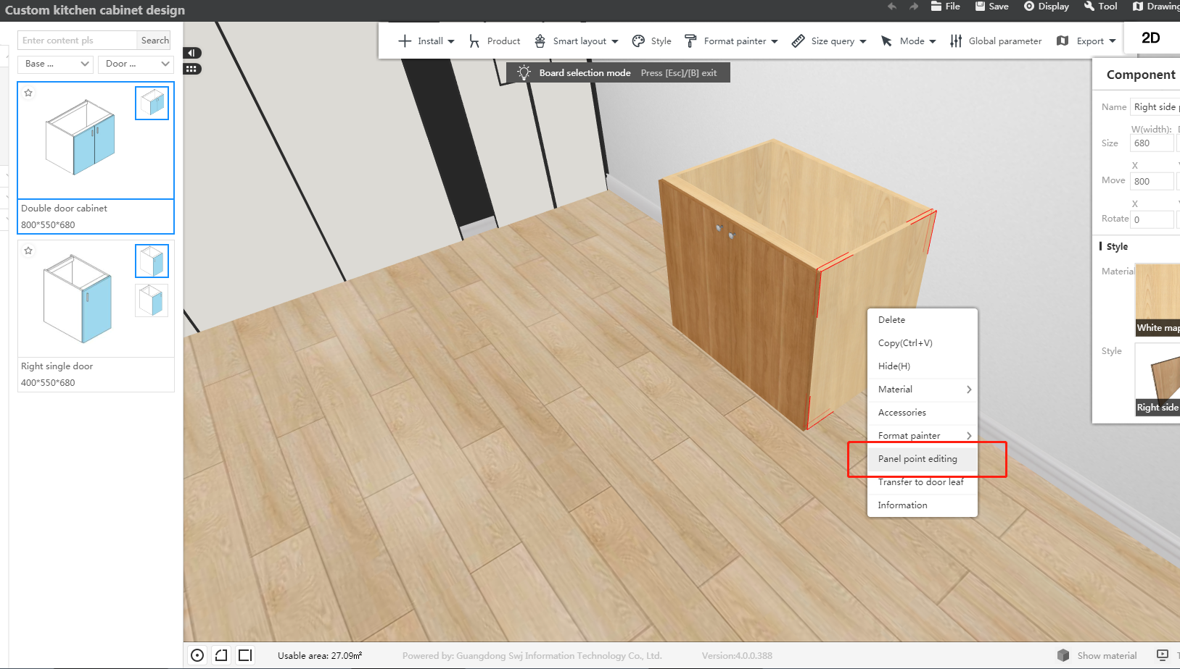
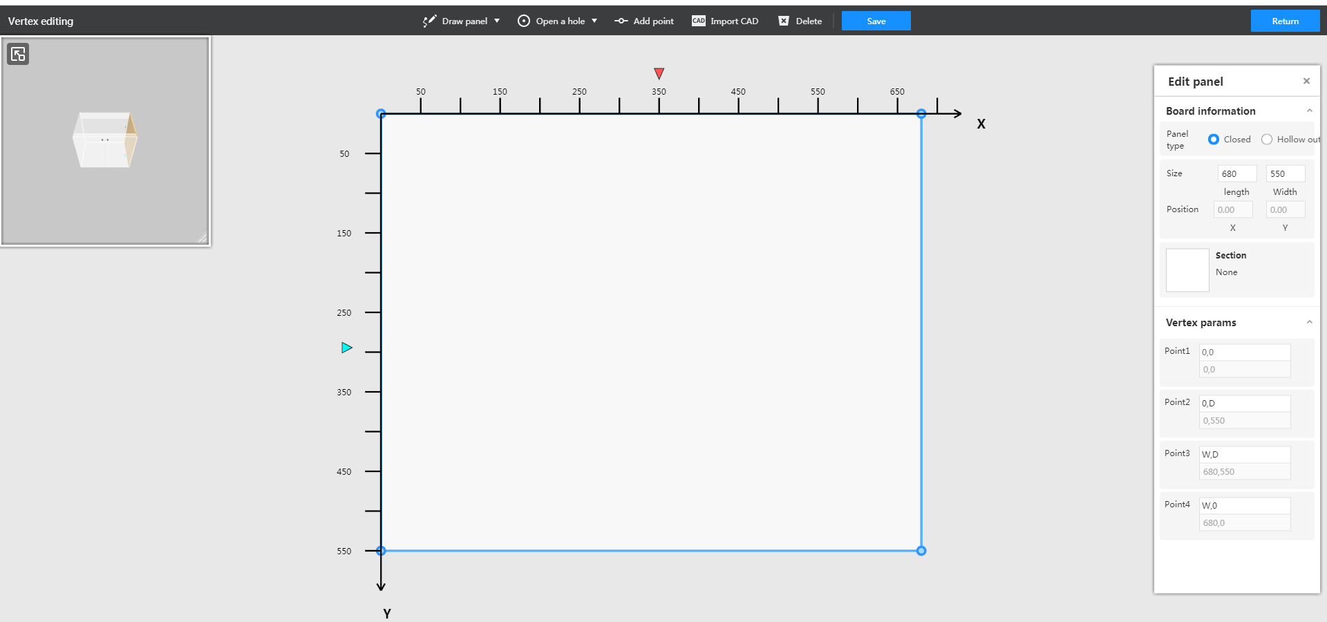

The above is all contents of the update version!

